JSP (Java Server Pages)
Harsha 01/10/2000
Modified by JW 4/21/00
Purpose: Develop program in Java Server Pages (JSP)
There are several ways to do JSP, JSWDK, Allaire’s JRun, or other Java app server.

JSWDK
The most primitive way is using Sun Javasoft JSWDK. First, download the java server web development kit (jswdk-1.0.1) and related documents from http://www.javasoft.com/products/jsp/index.html. Follow the instruction to install at d:\java\jsp\ jswdk-1.0. (Be sure that JDK already installed previously)

To Run the program written in JSP:
1. Go to JSP folder (e.g., d:/java/jswdk-1.0.1/examples/jsp/) and create a new directory (e.g., john). Put all your html, jsp, and other resource files (gif, etc) in this folder, or
Put all of your Beans (class files) under /examples/WEB-INF/jsp/beans. The startserver script automatically adds these classes to CLASSPATH at runtime.
**Make sure to set classpath = [JDK home]\lib\tools.jar (e.g., d:\java\jdk122\lib\tools.jar)
or Control Panel|System|Environment set path and classpath for both system variables and user variables.

2. Run the startserver at DOS command prompt (If the server is already running, stop and restart it.). If successful, one additional DOS screens will show up. Note: the JSP listening port is defined as 8080 in the second screen (see webserver.xml for server definition). If java file is needed for JSP (e.g., to generate documentation using javadoc, change the statement in startserver.bat to:
start java –Djsp.keepgenerated=true com.sun.web.shell.startup 1% 2% 3% ….%9
(default is false, i.e., the temporary java files will be cleaned up immediately after class files generated. The resulting java files will be placed under the subdirectories of work)
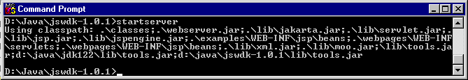
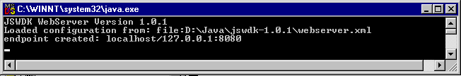
3. Surf with a browser to http://localhost:8080/examples/jsp/john/filename.jsp

RESIN (a fast stand-alone java web server or add-on java engine)
Resin provides a standalone web server. In our benchmarks, it actually serves static pages faster than Apache!
httpd | Standalone Web Server
srun | Apache/Netscape/IIS servlet engine
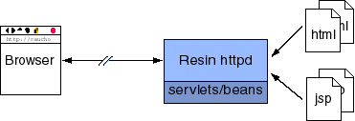
To start the Resin web server on Win32, type: bin/httpd (or click it)
**: If the program httpd already in memory, Java.net.BindException (Address in use, bind) will be thrown. Use Task manager to check it.
The default port is 8080, so use http://localhost:8080 in your browser. (If change <httpd-port>80</httpd-port> in conf/resin.conf, then http://localhost/ can be used directly.) The JSP and html files are located in /doc (defined in <app-dir>doc</app-dir>) and all servlets and beans are in /doc/WEB-INF/classes (resin will automatically compile java and save class in the same dir). Although mutiple virtual hosts and mutiple web-apps are supported, for a simple site with only have a single host and a single web-app, the resin1.1/conf/samples/deploy.conf sample is a good starting point.
Now, add a file resin1.1/doc/test.jsp containing the following:
<%@ page language=java %>
2 + 2 = <%= 2 + 2 %>
You should see the page '2 + 2 = 4'.

The Resin Web Server can be installed as an NT service.
To install [remove] the service, use bin/httpd –install [-remove]
Then the Resin Server is available in the Control Panel/Services panel.

JRun
JRun from Allaire is a free (unlimited in time but limited service, of course) software. It can be used as a standalone Web Server (JSP and servlet enabled), or JSP/Servlet plug-in engine for other popular web servers (IIS, Apache, Netscape, etc.)

Download JRun 2.3.3 form http://www2.allaire.com/products/jrun/ and install.
For Jrun Pro 2.3.3: JR23EVW-5655985235
For Jrun 3.0 Server:
* Professional Edition Eval. Serial Number: JR300P1-0103-2343-7518
* Enterprise Edition Eval. Serial Number: JR300E1-0103-9823-4507

The default root directory for JSP, HTML, and other resources files is d:/Java/jrun/jsm-default/services/jws/htdocs/. The d:/Java/jrun/jsm-default/ is where to run Jrun Administrator (startadmin.bat), begin and terminate JRun Application Manager (startjsm.bat and stopjsm.bat)). The three batch files are located in d:/Java/jrun/jsm-default/. In JRun Administrator (on Windows Task Bar), select jws (JRun Web Server) and Service Configuration, the Path Settings define virtual path “/” with the physical path “services/jws/htdocs/“. Therefore, the default root directory for JSP, HTML, and other resources files is d:/Java/jrun/jsm-default/services/jws/htdocs/.
In JWS’s General Config, Endpoint Settings defines the Service Port as 8000 (can be configured to other number). The JavaBean files are placed in d:/Java/jrun/jsm-default/classes, and the servlets are located in d:/Java/jrun/jsm-default/servlets.

After placing all the relevant files, one can test HTML and JSP files with browser:
http://localhost:8000/jsp/index.html (d:/Java/jrun/jsm-default/services/jws/htdocs/ jsp/index.html)
http://localhost:8000/jsp/jspsamp/jspexamples/hello.jsp (d:/Java/jrun/jsm-default/ services/jws/htdocs/jsp/jspsamp/jspexamples/hello.jsp)
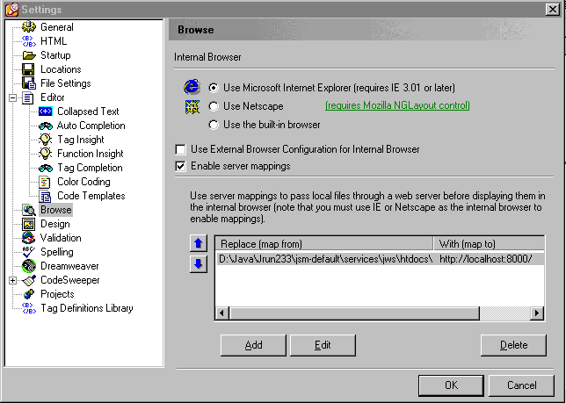

HomeSite

Use features-rich HTML editor HomeSite with a JSP-enable server, one can enjoy the front-end (WYSWYG and Drag&Drop editor) and back-end development (JSP) at the same time.

1. First download evaluation version of HomeSite 4.5.1 from Allaire (http://commerce.allaire.com/download/) and install.
2. Configure to use external webserver to process the pages. Set the Options/Settings/Browse with “Enable server mappings” and add mappings: Replace (map from) the root directory of JSP and HTML files-- …\htdocs\ with (map to) the virtual surfing URL—http://localhost:8000/
3. Edit the JSP in Edit mode, and view the result (as a client) in Browse mode.
4. View resin1.1/log/error.log for any compilation or runtime error.

JSP with Weblogic
- All the JSP and HTML source files are located in weblogic/myserver/public_html and subdirectories.
- All Java Beans (.java and .class) are located in weblogic/classes. (**: All properties have to be explicitly initialized.) For calling the bean IntellCh.java in weblogic/classes/carday, the JSP statement is
<jsp:useBean id="ICBean" class="carday.IntellCh" scope="request"></jsp:useBean>
- Path info for files in Reader/Writer are all the way to the root (/usr/local/weblogic/ myserver/public_html …)
- The resulting java files from jsp are stored in ..myserver/classfiles/examples/_jsp/. It will be weblogic/myserver/classfiles/examples/_jsp/_john/_test/_x.java for
weblogic/myserver/public_html/john/test/x.jsp
- “/usr/local/weblogic/myserver/classfiles/examples/jsp/_john/_IntellChoice1.java:121: Attempt to reference method setYear in class carday.IntellChoice as an instance variable. probably occurred due to an error in john/IntellChoice1.jsp line 26: ICBean.setYear=1997; ==> Change to ICBean.setYear(1997);

IDE with JSP

So far, the IDE support on JSP is still not very popular. Only the newest Inprise Jbuilder3.5 Enterprise, Sun Forte for Java, and Visual Café 4 Enterprise support JSP.

Web Server + JSP Engine
JavaServer Pages (JSP) are supported in Jigsaw, by using one of the JSP Engines availables: GnuJsp (JSP 1.0), Caucho Resin (Servlet 2.2, JSP 1.1), Jakarta Tomcat (Servlet 2.2, JSP 1.1). We describe here how to configure Jigsaw to use those engines
First of all, download your favorite JSP Engine (see the links on the left) and read its installation procedure. You will probably have to update your CLASSPATH. Please check it before going to the next step and don't forget to restart Jigsaw after modifying the CLASSPATH.
Now, configure the JSP Engine servlet, you'll probably need to configure some parameters. For more details on servlet installation read the servlet documentation, and the documentation of your JSP engine.
The next thing to do is to map jsp files to the JSP servlet, a request coming on a jsp file will be redirected to the JSP Servlet. For that we use a ServletMapperFrame.
Now setup the indexer (eg: the default indexer). Under the "extensions" node add the "jsp" extension using a FileResource associated to a ServletMapperFrame. Then, in the ServletMapperFrame, set the "servlet-url" field to the JSP Servlet URI (eg: /servlet/jsp). (Note, this will work with Jigsaw 2.0.2 and up)

Appendix. JSWDK FAQ
This document lists some frequently asked questions about the JavaServer Web Development Kit (JSWDK).
What environment variables do I need to set to use the JSWDK?
You need a correct version of the JDK in the CLASSPATH variable. (For Unix, JDK 1.1.x or 1.2. For Windows, JDK 1.2.)
If you are using JDK 1.2, you also need to do one of the following:
- Set JAVA_HOME to the JDK directory. (e.g., d:\java\jdk122)
- Put tools.jar in the CLASSPATH variable.
All other necessary classes and jar files are managed by the startserver script or batch file.
Where are the classes for JSPs and Servlets?
The files are as follows:
- webserver.jar -- class files for the Servlet Engine
- lib/jspengine.jar -- class files for the JSP Engine
- lib/servlet.jar -- public APIs for Servlets
- lib/xml.jar -- classes for parsing XML documents
Can I combine these classes with other webservers?
The JSP engine uses only the public portion of the Java Servlet 2.1 API. In theory, it could run on other Servlet engines that support the Servlet 2.1 API. Sun has not tested this release on any Servlet engine other than the one in the JSWDK.
Where do I put my JSP sources and beans?
If you are testing JSP pages without creating a separate web application, you can use the default "Example" application. If you are creating a new web application, refer to the question on installing a new web application in this FAQ.
To use the default "Example" application:
- Put all of your JSP source files in /examples/jsp, either directly or in their own subdirectory.
- Put all of your Beans (class files) under /examples/WEB-INF/jsp/beans. The startserver script automatically adds these classes to CLASSPATH at runtime.
- If your server is already running, stop and restart it.
- Invoke your JSP pages using http://locahost:8080/examples/jsp/yours.jsp
What is a web application?
A web application is a collection of resources that is mapped to a specific Uniform Resource Identifier (URI) prefix. These resources may include JSP pages, Servlets, HTML files, and images.
For example, all of the resources related to baseball can be assembled into a "baseball" directory. All requests starting with "/baseball" could then be mapped to this application.
How do I install a new web application?
- Create a directory within the JSWDK directory for the web application. In the following examples, we will call this WEBAPP. The directory should have the same structure as the Examples directory, with subdirectories for jsp, servlets, WEB-INF, and images, if appropriate. One way to do this is to copy the Examples directory and then edit the files as necessary.
- Add a new application to the JSWDK by editing the file webserver.xml in the root JSWDK directory.
For example, to create a baseball application, you would make the following additions to the file (at the appropriate location):
<WebApplication id="baseball0" mapping="/baseball" docBase="baseball="/>
Read the webserver.xml file for more details on the syntax and options. See the questions below for installing Servlets, JSP pages and Beans.
How do I install Servlets within my web application?
Use the following procedure, substituting your application directory for WEBAPP:
- Compile the Servlet and determine which web application context you will add it to.
- Add the Servlet class file to the WEBAPP/WEB-INF/servlets directory.
- Activate the newly installed Servlet by registering (adding) the servlet in the WEBAPP/WEB_INF/servlets.properties file. See the Examples/WEB-INF/servlets file for an example.
- Optionally, you can map the Servlet to URI requests relative to the context in which the Servlet is located by adding an entry in the WEBAPP/WEB-INF/mappings.properties file. See the Examples/WEB-INF/mappings.properties file for an example.
- Restart the server.
Access the Servlet using the following method, where WEBAPP is the web application URI name, and SERVLET_NAME is the base name of the servlet:
http://localhost:8080/WEBAPP/servlet/SERVLET-NAME
If you have associated a URI path mapping to your servlet, you can access it as follows, where EXTENSION is a file time extension and MAP-PATH is an associated URI MAP path:
http://localhost:8080/WEBAPP/foo.EXTENSION
--- or ---
http://localhost:8080/WEBAPP/MAP-PATH
How do I install JSP pages and Java Beans in a web application?
- Put the JSP source files in any directory under your application directory (/WEBAPP in the examples above).
- Make sure that the compiled beans are in the CLASSPATH. This can be done either by setting the CLASSPATH manually or by editing the startserver script.
- Edit the file WEBAPP/WEB-INF/mappings.properties and the file WEBAPP/WEB-INF/servlets.properties to map ".jsp" in the URI to the JSP Servlet which will process the jsp file. (See the property files in /examples/WEB-INF/ for an example. Your mapping should be similar.)
- Finally, restart the server.
You can invoke your new JSP page using a URI similar to the following:
http://localhost:8080/WEBAPP/yourfile.jsp

How are the URIs mapped at the server?
The web-server matches the beginning of the requested URI with the prefixes of all contexts (web-applications). If no context matches, it uses the default context instead.
How do you pass data from a Servlet to a JSP page?
See the JSP examples included with the JSWDK for samples of passing data from a Servlet to a JSP page, and from a JSP page to a Servlet.

What do the different init parameters mean?
keepgenerated:
Indicates whether or not to keep the generated Java file. The options are true or false. Setting this to true retains the generated files. Setting it to false deletes these files after compilation.
scratchDir:
This sets the location for the work directory, which will be created for storing all generated code. This can be set to any directory. The work directory will be created under the DocBase.
largeFile:
True or false. Set this to true for large files. When this value is true, all static HTML is stored in a separate data file.
sendErrToClient:
True or false. If this parameter is set to true, all compilation/parsing errors will be sent as part of the response to the client.
ieClassId:
This parameter is used to activate the IE plug-in. The default value is set for IE 4 and 5. If the classID for IE changes in the future, this parameter will be helpful.
What does a 404 error mean?
It means the server was not able to locate the resource you requested. This may be due to one of two reasons:
- The URL you entered was wrong or had a typo.
- The URL could not be resolved with the current "docsBase." If you are running your own web applications, please read the questions related to installing your own web application.
What does a 505 error mean?
A 505 error represents an "internal server error" encountered while processing your request. To find out more about the error, study the trace at the server window.
These errors can occur when translating JSP source to a Servlet. Translation-time errors typically occur because of a syntax error in the JSP file or in the generated Java file. Use the error message at the server window for debugging.
Errors can also occur at request time. Again, refer to the server-side trace for information about the specific problem or exception.

