JSWDK
Harsha 01/10/2000
Modified by JW 4/21/00

Purpose: Use JSWDK-1.0.1 to test Java Server Pages

Download the java server web development kit (jswdk-1.0.1) and related documents from http://www.javasoft.com/products/jsp/index.html. Follow the instruction to install at d:\java\jsp\ jswdk-1.0. (Be sure that JDK already installed previously)

To Run the program written in JSP:
1. Go to JSP folder (e.g., d:/java/jswdk-1.0.1/examples/jsp/) and create a new directory (e.g., john). Put all your html, jsp, and other resource files (gif, etc) in this folder.

2. Run the startserver at DOS command prompt. If successful, the following two DOS screens will show up. Note: the JSP listening port is defined as 8080 in the second screen (see webserver.xml for server definition).
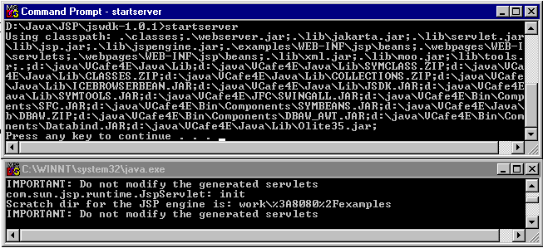
3. Surf with a browser to http://localhost:8080/examples/jsp/john/filename.jsp

